Governing equation for transient heat conduction derivation:

∂T∂t=α∂2T∂x2

-5*10-5=α∂2T∂x2

∂T∂x=-5*10-5αx+C1

T=-5*10-5αx22+C1(x)+C2

Crank-Nicolson scheme derived in lecture notes:

λ2Ti+1n+1-(1+λ)Tin+1+λ2Ti-1n+1=λ2Ti+1n+(1-λ)Tin+λ2Ti-1n

**Program Code:**

**Tridiagonal Code**

function x = Tridiag(e,f,g,r)

n=length(f);

for k = 2:n

 factor = e(k)/f(k-1);

 f(k) = f(k) - factor*g(k-1);

 r(k) = r(k) - factor*r(k-1);

end

x(n) = r(n)/f(n);

for k = n-1:-1:1

 x(k) = (r(k)-g(k)*x(k+1))/f(k);

end

**Main code**

L=1; dx = L/30; alpha=174*10^-6; C_1=-79.8563; C_2=100;

dt =(.5*(dx^2))/alpha; lam=((alpha*dt)/((dx)^2)); converge=-5*(10^-4);

a=lam/2*ones(1,19);

a(1)=0';

a=a';

b=(-1-lam)*ones(1,19)';

c=lam/2*ones(1,18);

c(19)=0';

c=c';

Temp(1:21,1)=400;

t_1=100; t_2=20; t_i=400;

k=1;

load(1)=-((lam/2)*Temp(2,k)+(1-lam)*Temp(1,k)+(lam/2)*t_i)-(lam/2)*100;

load(19)=-((lam/2)*t_i+(1-lam)*Temp(19,k)+(lam/2)*Temp(18,k))-(lam/2)*20;

for i=2:18

   load(i)=-((lam/2)*Temp((i+1),k)) -((1-lam)*Temp(i,k)) -((lam/2)*Temp((i-1),k));

end

[Tn(1:19)]=Tridiag(a, b, c, load);

Temp(1:19,(k+1))=Tn;

t1=Temp(:,(k));

t2=Temp(:,k+1);

deltaT=(t2 - t1)/dt;

dTdt(k)=mean(deltaT);

for k=2:36000

   load(1)=-((lam/2)*Temp(3,k)+(1-lam)*Temp(2,k)+(lam/2)*t_1)-(lam/2)*100;

   load(19)=-((lam/2)*t_2+(1-lam)*Temp(20,k) +(lam/2)*Temp(19,k))-(lam/2)*20;

   for i=2:18

       load(i)=-((lam/2)*Temp((i+2),k)) -((1-lam)*Temp(i+1,k)) -((lam/2)*Temp((i),k));

   end

   [Tn]=Tridiag(a,b,c,load);

   Temp(2:20,(k+1))=Tn;

   Temp(1,k+1)=100;

   Temp(21,k+1)=20;

   t1=Temp(:,(k));

   t2=Temp(:,k+1);

   deltaT=(t2 - t1)/dt;

   dTdt(k)=mean(deltaT);

   if dTdt(k)>=converge

       k1=k-1;

       break

   end

end

fprintf('Determine the time at which the mean value of ∂T/∂t corresponds to the value of -5e-5 (deg C/sec) in %4f seconds.\n',k1*dt)

disp(' ');

steps=1:length(dTdt);

time=dt.*steps;

position=linspace(0,1,21);

figure;

plot(time,dTdt);

grid on

xlim([0 600])

xlabel('Time (sec.)');

ylim([-15 5])

ylabel('dT/dt, (^oC/sec.)');

title('dT/dt vs. Time');

T = @(x) -5e-5/(alpha)*(x^2/2)+C_1*x+C_2;

for j=1:21

   numerical(j)=feval(T,position(j));

end

figure;

plot(position,Temp(:,413),'Color','b'); hold on;

plot(position,numerical,'Color','k'); hold on;

grid on

xlabel('Position x, m');

ylabel('Temperature (^oC)');

title('Temperature vs. Position');

legend('Approximate Temperature','Analytical Temperature');

t_0=Temp(:,1); t_1=Temp(:,20); t_2=Temp(:,100); t_3=Temp(:,200); t_4=Temp(:,300); t_5=Temp(:,600);

dx1=linspace(0,L,21);

figure

hol

plot(dx1, t_0,'r*')

plot(dx1, t_1,'bo')

plot(dx1, t_2,'r--')

plot(dx1, t_3,'p')

plot(dx1, t_4,'r*')

plot(dx1, t_5,'k--')

grid on

ylim([0 450])

xlabel('x (m)');

ylabel('Temperature (^oC)');

title('Temperature vs. Position');

legend('t=0','t=302.5','t=472.6','t=685.0','t=898.3','t=1969.98');

approx=[Temp(:,413)];

analytical=numerical';

err=((abs(approx-analytical))./analytical)*100;

disp('  Numerical      Analytical    Percent Error')

for i=1:21

   fprintf('   %7.4f  %10.4f  %8.3f \n',approx(i),analytical(i),err(i))

end

The amount of time it takes to converge to -3*10^4 C/s is 43726.90 seconds>> Untitled

Determine the time at which the mean value of ∂T/∂t corresponds to the value of -5e-5 (deg C/sec) in 1973.180077 seconds.

|  |  |  |
| --- | --- | --- |
| **Numerical** | **Analytical** | **Percent Error** |
| 100.000 | 100.000 | 0.000 |
| 96.420 | 96.007 | 0.430 |
| 92.829 | 92.013 | 0.887 |
| 89.218 | 88.018 | 1.363 |
| 85.577 | 84.023 | 1.850 |
| 81.897 | 80.027 | 2.337 |
| 78.171 | 76.030 | 2.815 |
| 74.391 | 72.033 | 3.273 |
| 70.552 | 68.035 | 3.700 |
| 66.650 | 64.036 | 4.083 |
| 62.683 | 60.036 | 4.409 |
| 58.650 | 56.036 | 4.666 |
| 54.552 | 52.035 | 4.838 |
| 50.391 | 48.033 | 4.909 |
| 46.171 | 44.030 | 4.861 |
| 41.897 | 40.027 | 4.672 |
| 37.577 | 36.023 | 4.314 |
| 33.218 | 32.018 | 3.747 |
| 28.829 | 28.013 | 2.913 |
| 24.420 | 24.007 | 1.720 |
| 20.000 | 20.000 | 0.000 |

**Plotted data of mean values** (∂T∂t) **vs. Time**

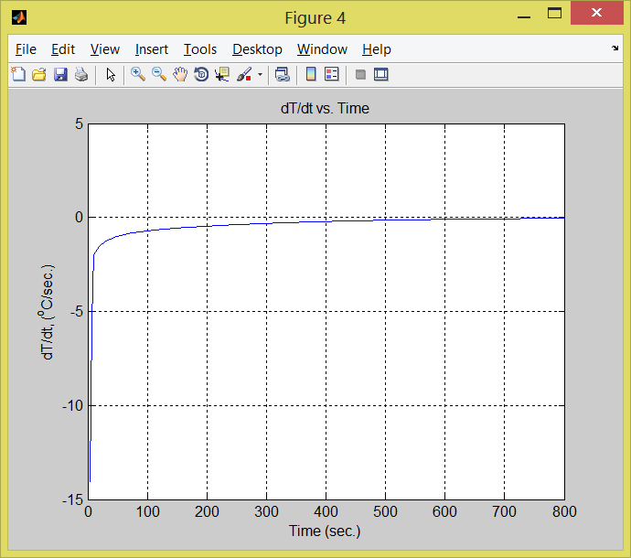

**Plotted results that compared numerical and analytical values**

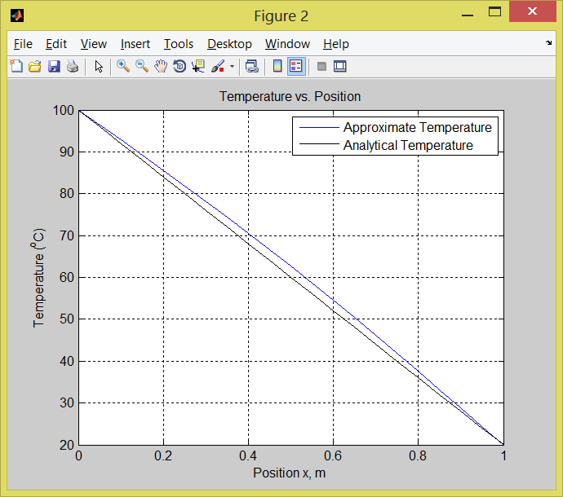

**Plotted values for six different stages between the initial and steady state conditions**

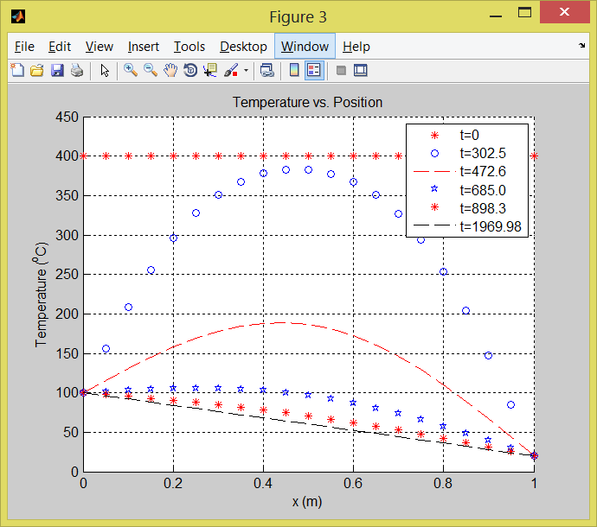

**Discussion**

* From the first graph, we can see that ∂T∂t **🡪 0 as time 🡪 ∞**.
* From the second graph, the percentage error starts and ends with zero where the analytical and numerical temperature values resembles the shape of the bell curve.
* From the third graph, we can see the temperature distribution at different stages between the initial condition and the steady state.

Conclusion

In this project, we have solved the transient conduction heat transfer equation. We were asked to solve this equation analytically and numerically, compare the results and find the %error. For the analytical solution, we used the Crank-Nicolson method to derive the finite-difference equations. We used tridiagonal function from the book for the numerical solution.